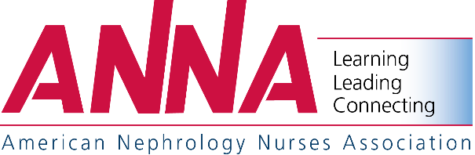

2018 National Symposium
April 15-18, 2018 – Las Vegas, Nevada
(Westgate Las Vegas Resort)
APPLICATION FOR REGISTRATION STUFFER PROGRAM

As an exhibitor this year in Las Vegas, Nevada, you can include your product literature or sales brochures in the attendee’s registration materials.

Benefits:
- Enables you to distribute your sales and promotional literature to attendees
- Alerts your customers of your products and services
- Encourages your customers to visit your booth

Brochure Size(s):
- Single Brochure no larger than 8 ½" x 11"
- One Unit Piece, 4 pages maximum (must be folded to be no larger than 8 ½" x 11")

Quantity – 1,200 pieces
Pricing:
- One Piece - $1,475
- Two Pieces - $2,075
- 20% Discount to participants that advertise a full page or larger within
  - the special March/April Symposium issue of Nephrology Nursing Journal or
  - within the Symposium Program

Deadlines:
- Reservation – February 16, 2018
- Receipt of Pieces – March 2, 2018

- YES, we will participate in the Registration Stuffer Program during ANNA's 2018 National Symposium as follows:

Number of Items

- Enclosed is our payment for this service. (ANNA Tax ID No. 23-7189008) $1,475 for one piece or $2,075 for two pieces. A 20% discount is available for advertisers (full page or larger) within the March/April 2018 issue of Nephrology Nursing Journal or within the 2018 National Symposium Program.

Amount Due $
Less Applicable Discount $
Total Due - Prepayment Required $

- We understand that the deadline to commit to this ANNA program is February 16, 2018. 1,200 pieces will be forwarded to ANNA by March 2, 2018.

Exhibitor
Address
City State Zip
Phone FAX E-mail
By Title
Signature Date

Send Completed Application, Payment & Pieces (1,200) To:
ANNA Registration Stuffer Program c/o Anthony J. Jannetti, Inc. Attention: Susan Iannelli
Postal - Box 56 Pitman, NJ 08071-0056
UPS/Overnight Service – 200 East Holly Avenue Sewell, NJ 08080
856-256-2376 FAX 856-589-7463

